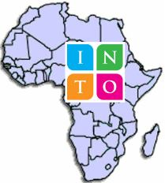
INTO Africa Group

Report of a conference held in Nairobi, 29th February – 1st March 2020

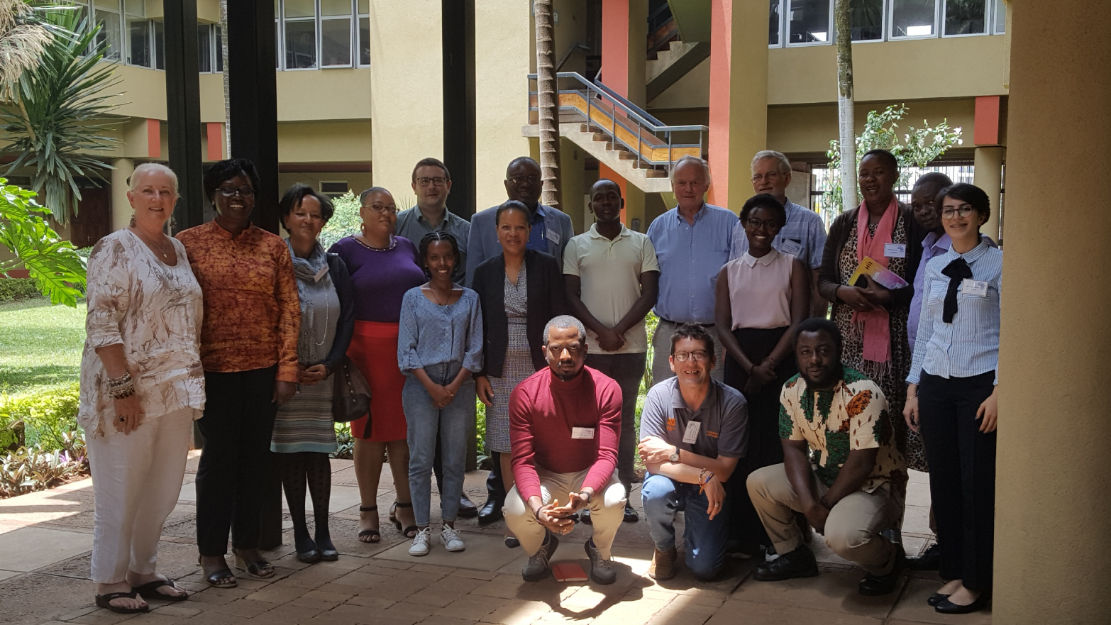

Kampala, March 2020
1. Background
The INTO Africa Group is a loose association of heritage-focused organisations from across the continent. A need had long been expressed to form a group of INTO African members (or would-be members) that would promote their distinct identity, within the broader INTO family of organisations.
The Group has been in existence for a few years but had as yet only met during the bi-annual INTO conferences. The idea a conference had been mooted some years ago and it was originally planned to hold such a meeting in Zimbabwe but, owing to the difficulties currently faced in the country, this was relocated to Nairobi.
The one and ½ day event, immediately followed an inspiring 2-day Symposium organised by the British Council at the same venue (the National Museum of Kenya) on “Culture Grows – Between Yesterday, Today and Tomorrow.”
The organisation of the INTO Africa Group conference was supported by the INTO secretariat (who generously provided a grant of UKL 5,000 to cover air fares and other costs), by the National Museum of Kenya (who kindly provided their Board Room venue free of charge). The preparatory work was undertaken by CCFU (currently chair of the Group) and through a series of webinars (electronic meetings) held in the previous months to discuss agenda, venue and participation.

2. Objectives, programme and participation
Twenty-two people attended the conference, representing 8 countries (Nigeria, the United Republic of Tanzania, Kenya, the UK, the Seychelles, Ethiopia, Zimbabwe and Uganda) and two international organisations (ICCROM and UNESCO). Of these, the Zimbabwe National Trust, the Zanzibar Stone Town Society, Heritage Watch Ethiopia and the Cross-Cultural Foundation of Uganda are registered members of INTO.
The objectives of the conference and the programme, as well as the names of the participants can be found as an Annex.

3. Proceedings – Day 1
After a brief round of introductions and thanks to the NMK for providing the venue, the objectives and proposed programme were reviewed and accepted.
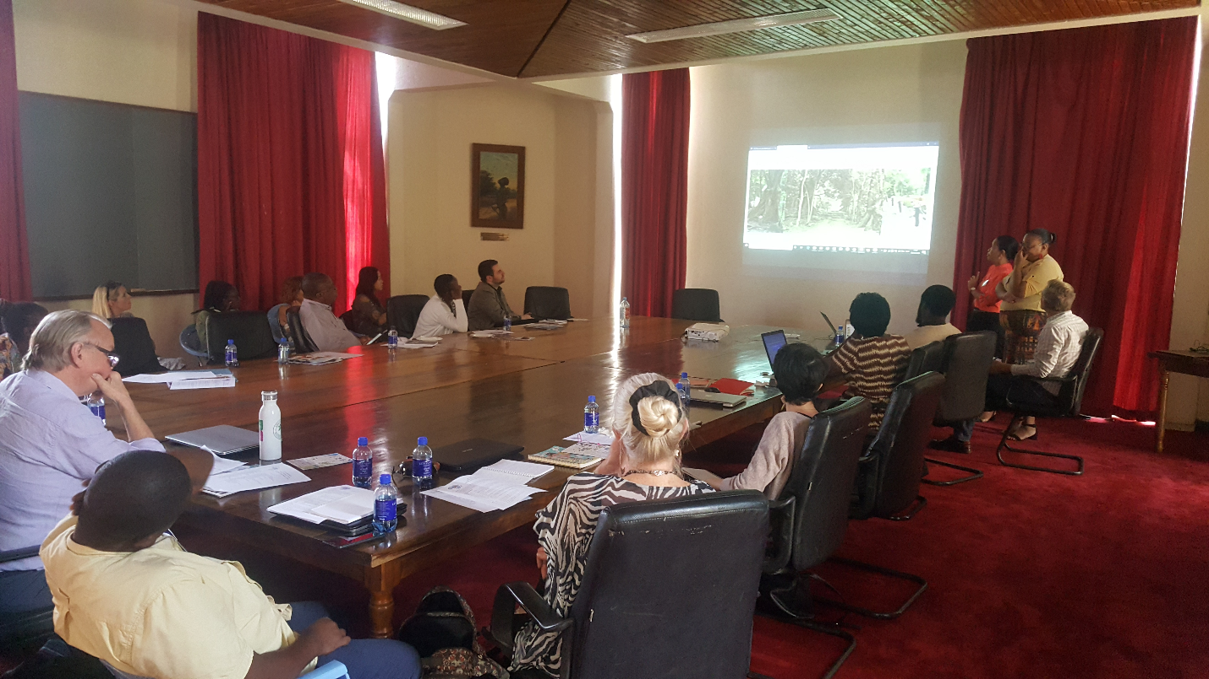
The National Officer for Culture at the UNESCO Nairobi office, Judy Ogana, then gave an opening presentation on “Safeguarding Heritage in East Africa – stories of success”. Having defined the indicators of “success” in terms of identifying sites; participation of both government and local population (especially youth) in safeguarding; innovation and “future-proofing” (sustainability, climate change resilience), several examples of success were demonstrated with, in the region, the transmission of weaving and thatching skills at Kasubi Tombs in Kampala to a new generation of artisans; investment in sea defences at Fort Jesus in Mombasa; the “superheroes” app. on “our culture”; engaging youth in different projects, such as CCFU’s project with universities in Uganda; and the national competition for Kenyan youth, with prizes entailing visits to heritage sites.
The different organisations represented around the table then shared their success stories, which proved many and diverse!
- The Zimbabwe Trust and their work on craft development with youth, all undertaken by volunteers (the Trust, created by an Act of Parliament in the 1960s, no longer gets State support). The National curriculum incorporated heritage education and indicates the National Trust of Zimbabwe as a key player. Engagement with CCFU has encouraged further work with youth
- Heritage Watch in Ethiopia, their survey of historical buildings with university students and tours of heritage buildings in the capital city and their engagement with government.
- The National Trust of England, Wales and Northern Ireland, “the mother trust” founded 125 years ago, that looks after thousands of properties and miles of coastline and other natural sites. Only 20% of the properties are profitable and fund the maintenance of the other sites. All these are looked after by 68,000 volunteers…
- The Cross-Cultural Foundation of Uganda supplemented its presentation on working with the youth in schools and universities (delivered the previous day at the British Council Symposium), with an overview of its work in conservation (preservation and promotion of historical buildings; using cultural resources to conserve the chimpanzees and their habitat) and in the area of cultural rights (culture for women’s empowerment; indigenous minority groups’ rights).
- Legacy 1995 from Nigeria on its work in re-purposing older buildings to ensure their economic viability in the current context.
- The Seychelles Heritage Foundation, a government-linked institution, and their work to preserve 4 heritage sites and to promote heritage education among the Seychellois youth.
- The Zanzibar Stone Town Society, with an accent on working with youth, developing their restauration and preservation skills (such as young women masons!), while highlighting the dangers of large-scale tourism.
- Kenya’s book bunk on their work to renovate public libraries while turning them into centres of cultural regeneration for local communities.
Oliver Maurice, from INTO, opened his presentation on “Understanding the National Trust model” by outlining different Trust models (Fully independent and property owning; influencing bodies maybe owning properties as exemplars; organisations dependent on government support; and organisations fully funded by the government). From this typology flowed questions on the existence or not of a membership (and its nature); the use of volunteers and/or staff; and on the nature of linkages with other organisations. To conclude a National Trust may be created because no other organisation preserves heritage; to promote national identity, or because heritage is being destroyed. The word “national” need not be used if the local context makes this difficult.
Oliver’s presentation led to several reflections:
- The need to work with government (but realising that, in some countries, the urgency of ensuring heritage preservation must come first); private public partnerships (PPPs) are gaining credence across the continent.
- The opportunity to start small and to collaborate with like-minded organisations, whether nationally or regionally.
- The necessity to involve youth at the outset.
- The need to make independent decisions and thus avoid any perception that a National Trust follows a “colonial model”; the creative sector can provide a source of inspiration.
- In some situations, management of property, rather than ownership, may be more appropriate, as well as a mix of grant and earned income.
After lunch, the film “The Language You Cry in” was shown, depicting a group of Afro-Americans’ long search for their cultural roots in Sierra Leone. This emotional search was shared to place an accent on intangible cultural heritage, of particular relevance to the African continent (rather than a focus on built heritage).
This was followed by a panel discussion bringing perspectives from INTO, the UK Trust, Nigeria and Zanzibar on “growing and financing heritage safeguarding and national trusts”. Various remarks and suggestions included:
- Many successful trusts in the higher-income countries meet local (rather than international/tourists’) demand and rest on local support – this needs to be nurtured (“this is my culture, so I will protect it”); and provide high quality services that generate income (trails, “provocative” and other special events, other forms of non-visitor income).
- Heritage and economic perspectives need to be carefully matched; the innovative re-use of buildings is often necessary to justify investments
- Sustainable funding needs donor, government and private sector involvement. A trust or NGO can have a commercial “arm” to cross-subsidise activities.

4. Proceedings – Day 2
Following a lively restaurant evening (courtesy of INTO) the second day (morning only) focused on the way forward for the Africa Group.
This was preceded by a presentation from Rim Kelouaze (ICCROM) who outlined the opportunities for the group arising from their new project “Youth, Heritage, Africa”, whose purpose is to “make heritage a source of development for Africa’s youth”, by engaging youth, fostering entrepreneurship in the heritage sector and strengthening heritage institutions. Activities include “heritage hubs” (spaces at heritage sites for innovation and entrepreneurship), currently active in Benin, South Africa and Kenya. Another 3 sites are being sought. ICCROM requests partnership proposals.
INTO’s Alex Bishop described INTO growing portfolio of activities and opportunities for African heritage organisations that join (exchange programmes, networking and linking, funding intelligence and small grants, participation at conferences, sharing best practice, coordinating international initiatives, learning through the “incubator initiative”, working on areas on common concerns). Alex also shared modalities for seeking membership.
What, on the other hand, can the group bring to INTO? Given the current low representation of African members within INTO (4 members out of a total of 80), the group can:
- Provide a stronger voice and a platform for African heritage organisations within INTO
- Help emphasise the intangible dimension of heritage within INTO’s thinking and practice
- Provide expertise on community participation in conservation projects and working with youth across the continent.
- Share information and involve other heritage organisations to reach out and register with INTO.
- Develop National Trust models relevant to the African context.

5. Plan of action and way forward
The Group thereafter defined a plan for action for the next two years. After much discussion the following was agreed, with two main proposals:

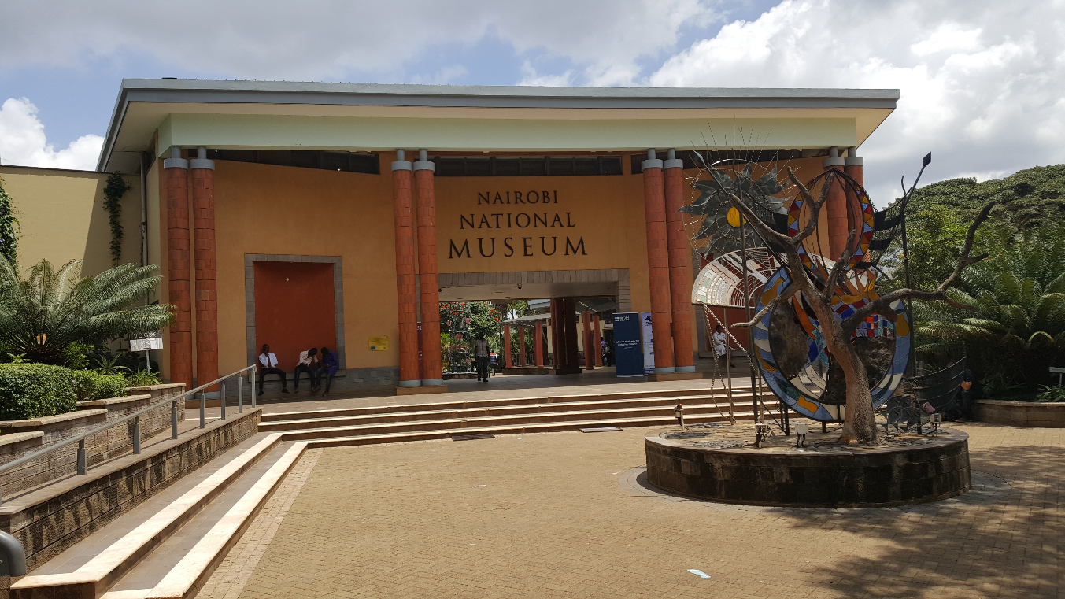
- Develop a common programme on Heritage Education and public outreach and engagement (Fundraised for as a group):
- Organising “Heritage Fairs”; crafts or music festival for INTO Africa group; support existing festivals
- Produce one publication that can be shared and used to enrich syllabi for African youth; competition
- Skills, materials and experience sharing

- Information exchanges and visibility– Explore ICT to share content on cultural heritage on the Africa continent:
- Website - Take responsibility for the INTO Africa webpage
- Regular and themed webinars (electronic meetings, teleconferencing - twice a year)
- Organise an online incubator hub (a closed Facebook)
- Produce a publication on INTO Africa experiences (on-line)
Immediate next steps were agreed as follows:
- Share (electronically) resources that the members have developed on heritage education (Justin to create a Google Drive) – within 1 week
- Develop a concept (and draft schedule) on a common programme on Heritage Education and public outreach / engagement (Alex+Sola within 2 weeks); Oliver to support on funding sources) – within 6 weeks
- Website - take responsibility for the INTO Africa webpage (Solomon+Mo+Cynthia) – May 2020
- Regular and themed webinars (at least two per year) (CCFU)
- Debrief on all actions through a webinar (within 6 weeks, John, CCFU)
- Organise an online incubator hub - a closed face book (Sola) (within a week) and maintained in consultation with Solomon + Mo + Cynthia.
- Produce an on-line Annual Newsletter on INTO Africa (Benjamine as Editor) + Alex – template) – February 2021 (or biannual)
The conference ended with a vote of thanks by Emily Drani from CCFU – thanks went to INTO for making the conference possible, to NMK for the venue and generous support, and to all participants for having made the effort to attend. Alex thanked Oliver and John (CCFU) for their work in organising the event.
Participants shared a feeling of a very productive time spent together, with renewed energy, new contacts and a sense of commitment.

ANNEX
Conference Objectives
- Exploring the relevance of the National Trust concept in the African context
- Reflecting on ways to grow and fund heritage conservation work in the local context
- Exchanging information on INTO Africa: Who is who? What do we do as heritage organisations?
- Developing the identity and a common platform for the INTO Africa group – what do we stand for, what can unite us? What can we do together?
- Action planning: what practical next steps – who does what?
Programme – Day 1
8.45 – 8.55 Welcome
8.55 - 9.15 Brief informal introductions, review of the proposed programme (CCFU)
9.15 – 9.30 Safeguarding heritage in East Africa – stories of success (Judy Ogana, National
Officer for Culture, UNESCO Nairobi Office)
9.30 – 11.00 Introducing our organisations
11.00 – 11.30 Tea break
11.30 – 12.15 Understanding the National Trust model (O. Maurice – INTO)
12.15 – 13.15 National Trusts – what experiences and relevance to Africa? (guided discussion)
13.15 – 14.15 Lunch
14.15 – 15.15 Film: The Language You Cry In (51 minutes) – the transmission of intangible heritage in the African context
15.15 – 16.30 Panel Discussion: Growing and financing heritage safeguarding and national trusts (A. Bishop – INTO; J. Scully (National Trust of England, Wales, Northern Ireland; Mogbolahan Ajala (Legacy 1995, Nigeria); Makame Juma (Zanzibar Stone Town Heritage Society)
16.30 Tea break
Evening: Informal interactions followed by dinner offered by INTO
Day 2:
8.45 – 9.00 The INTO Africa group: where do we come from? (CCFU)
9.00 – 9.45 What can INTO offer to the Group? (A. Bishop, INTO)
9.45 – 10.30 What can the Group offer INTO? (Various)
10.30 – 11.00 Tea break
11.00 – 12.30 Developing a common platform for the INTO Africa Group
12.30 – 13.30 Steering the group; practical way forward; closure
13.30 Lunch; departure

List of participants
Makame Juma | Zanzibar Stone Town Heritage Society
Oliver Maurice | International Organisation of Heritage Trusts
Justin Scully | National Trust of England, Wales and Northern Ireland
Willie Dhlandhlara | Zimbabwe National Trust
Emily Drani | Cross-Cultural Foundation of Uganda
Mogbolahan Ajala | Legacy 1995, Nigeria
Ṣọlá Akíntúndé | Legacy 1995, Nigeria
Alexanber Bishop | International Organisation of Heritage Trusts
Solomon Kifle | Heritage watch, Ethiopia
Betelehem Gebre Medhin | Heritage watch, Ethiopia
Esther Selassie Antohin | Heritage watch, Ethiopia
Linda Mboya | ICOM/NMK
John De Coninck | Cross-Cultural Foundation of Uganda
Maureen Anzaye | British Council
Angela Wachuka | Book Bunk
Sahar McTough | Book Bunk
Rim Kelouaze | ICCROM
Natasha Mbugguss a.i. | Aug 7th Memorial Park and Trust
Cynthia Mwendwa
Judy Ogana | National Officer for Culture, UNESCO Nairobi Office
Benjamine Rose | CEO, Seychelles Heritage Foundation
Miriam Cesar | Seychelles Heritage Foundation
Lin Goncalves | Zimbabwe National Trust

