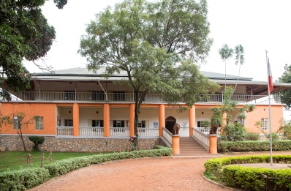

CCFU spent considerable time and effort to forge an alliance of different institutions, willing to participate in what could eventually be seen as a “collective project”, rather than that of an isolated NGO (there is no National Trust in Uganda).

With some coaxing, the Kampala city Authority, the Uganda National Museum , the Tourism Board and the Buganda Kingdom have all agreed to take part.

All participated in shortlisting the buildings and sites to be mapped.

A photographer was hired, and a team of three CCFU volunteers spent three weeks contacting owners or managers of buildings to seek their permission and to record their histories.

Later, a launch will be held and the map distributed to various points in town, including schools, universities, tourist hotels, the National Museum, etc.

But this is only step 1….

Kampala, the capital city of Uganda, has a relatively short but rich history. This town of approximately 3 million is the product of the ancient Buganda Kingdom as well as of 80 years of British colonialism.

In the rush to “modernise”, the city’s built heritage is under immense threat. Currently, there is little appreciation of the value of this legacy.

Even the most iconic buildings and sites are fast disappearing as pressure on land by property developers mounts in this already congested city.

The Cross-Cultural Foundation of Uganda (CCFU), a small organisation without the means to buy out any such developer, concluded two years ago that the only way to salvage the remnants of this heritage was to sensitise the public about its intrinsic value.

As an initial, low cost step, a map of historical buildings and sites in the city has been developed and is being marketed.

This opens the way to subsequent action to secure the future of Kampala’s built heritage for the next generations.

### Approach

## Objective

A journey through time – campaigning to preserve Kampala’s historical buildings and sites

Special points

of interest:

* Using a map as an initial, low-cost step to protect urban heritage under threat
* Forging an alliance between different insitutions to give the effort “weight”

# The Cross-Cultural Foundation of Uganda

Name of project

## INTO involvement & relevance to members

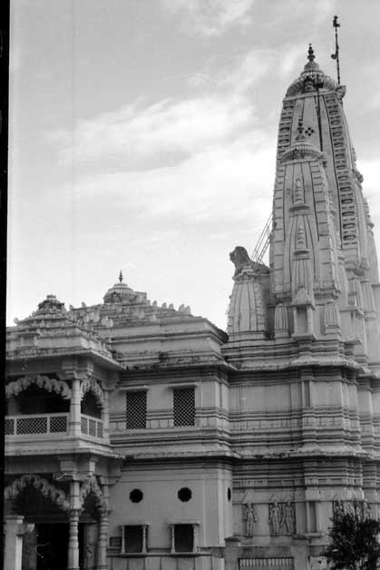

INTO provided CCFU with two key ingredients in the project:

1. The initial idea for this initiative was inspired by a visit by CCFU staff to Harare, Zimbabwe, where the National Trust of Zimbabwe had published a similar map some years back. This map both inspired us and provided us with a useful template. Linking with the Trust was only possible because of INTO’s networking platform.
2. INTO also provided an opportunity to raise funds for the project. In September 2014, the INTO secretariat (in conjunction with member Tesouros de Galicia) organised a fundraising walk in northern Spain. The funds raised by two CCFU walkers on this occasion provided more than 50% of the finance needed for the project

INTO members might learn from this low-cost, step-by-step approach to conserving urban heritage in danger, as well as from the usefulness of coalition-building in the face of powerful (and usually destructive) forces.

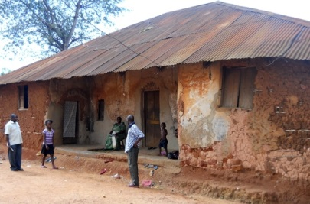

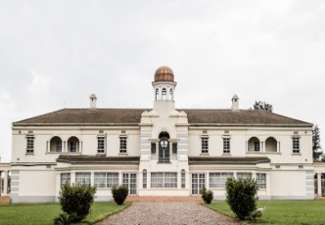

### Progress

**The Cross Cultural Foundation of Uganda**

Tel: +256 (0)393 294675

Address: Bativa Road, Makerere, Kampala

E mail: ccfu@crossculturalfoundation.or.ug

Website: www.crossculturalfoundation.or.ug

**INTO Contact**

Tel 44 (0)20 7884 7157

20 Grosvenor Gardens, London, SW1W 0DH, UK

E mail: into@nationaltrust.org.uk

http://internationaltrusts.org

## Contact Information

With the map completed and distributed, the next steps are being designed. These include:

1. Developing briefing notes on the history of the most important buildings and sites
2. Having the buildings marked by plaques
3. Mounting a campaign to have key buildings protected by law by both the city authorities and the central government
4. Encouraging the second largest city in the country (Jinja) to develop a similar project.
5. Building the interest and capacity of the owners/managers of selected buildings to preserve their heritage

