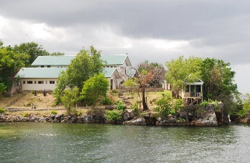

### Overview

## To safeguard the national heritage through protection, restoration, preservation and education.

Nelson Island is one of five islands off Trinidad’s west coast in the Gulf of Paria, comprising of approximately 8 acres.

Historically it was used as a landing and immigration depot, and quarantine facility for East Indian indentured immigrants during the period 1866 to 1917. The island still has one of the oldest buildings standing in Trinidad and Tobago.

Nelson Island remained largely unused until 1939, when it was used as a detention centre for a sole detainee, a renowned labour, political and religious leader, Tubal Uriah Butler, up until 1945.

During the 1970 Black Power Revolution, the property was again used as a detention centre to detain advocates of the movement and curb the spread of their ideologies.

The island has since been placed under the aegis of the National Trust, and work has been done to restore the largest building on the property, Building A, which formerly housed a mess hall, with work still to be done on other buildings on the island.

The National Trust has since undertaken to educate the public as to the importance of this historic property, by hosting events to commemorate all the people who would have been housed at the island over the years.

### Approach

Since there were three major periods of historical importance, events were hosted to highlight Indian Arrival, Tubal Uriah Butler and 1970 Revisited.

These events would provide an understanding of the East Indian indentured immigrant experience, as well as the Black Power Movement and the legacy of Tubal Uriah Butler.

This would be done through dissemination of information, creation of public awareness, on-site history education for school children and the general public and garnering of support for protection of the national heritage.

Activities to highlight each event included drama presentations of partial reenactments, guest lectures, cultural performances, photographic exhibitions, displays of books, craft and clothing, culinary demonstrations, language workshops, and tours of the island.

Arrangements were made with schools throughout the country and the general public notified to participate in these three events through Facebook, Emails, Radio, Newspaper advertisements.

Nelson Island Experience

Special points

of interest:

* Highlighting multiple layers of history of one site.
* Engaging the Secondary and Primary school students in educational experiences that they otherwise would not have access to.

# National Trust of Trinidad and Tobago

Issue 1

September 2015

Name of project

Sharing the historical importance of a place means that no piece of history should remain unsaid. Nelson Island has multiple layers of history and to ensure that every group was acknowledged required multiple events.

This year, 2015, marks the 45th anniversary of the 1970 Black Power Revolution which started off the three events in April. Followed by Indian Arrival in May and Tubal Uriah Butler in June. The public was charged a minimal fee to experience Nelson Island as it once was for each historical event. However the Secondary and Primary school students were free of charge on a separate day. This facilitated the education requirement of the National Trust Act and was well received by all schools. Over 36 schools nationwide attended the events. This not only introduced the island to the students but the multiple histories of Nelson Island was introduced to the school curriculum for the first time.

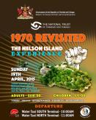

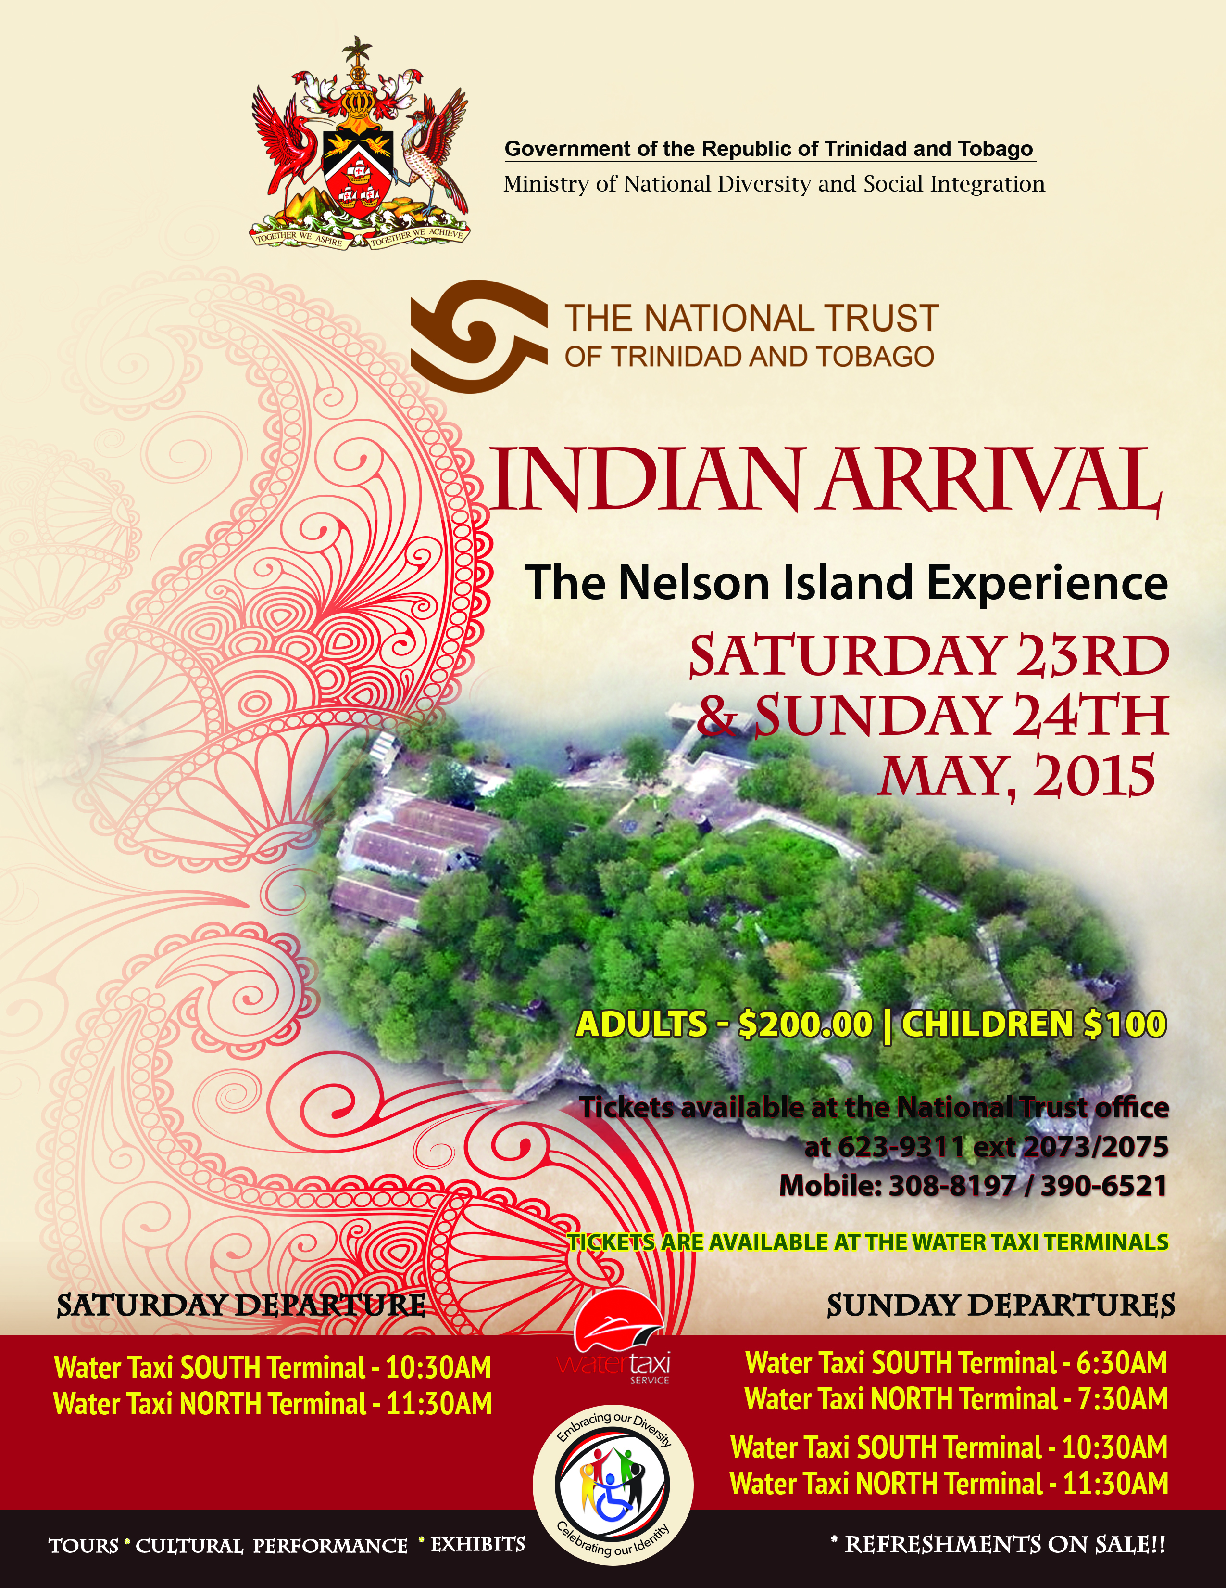

Due to the success and positive feedback of these three events, both as a fundraiser and as an educational and interpretive experience, the National Trust of Trinidad and Tobago is now embarking on smaller monthly tours to reach a wider audience and educate as many as possible.

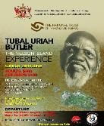

### Progress



## Contact Information

**Organisation Contact**

Tel: 1(868) 623-9311 ext 2073/2074

Address: 35 A Wrightson Road, Port-of-Spain

E mail: nationaltrust.tt@gmail.com

Website:



**INTO Contact**

Tel 44 (0)20 7884 7157

20 Grosvenor Gardens, London, SW1W 0DH, UK

E mail: into@nationaltrust.org.uk

http://internationaltrusts.org