Tesouros de Galicia intended to promote the renewal of the English Way hand in hand with the International National Trusts Organisation and the Provincial Council of A Coruña. To achieve this aim different Spanish and British groups got involved in order to spread the contents and values of the Way.

During four months, a team formed by multidiscipline professionals worked in this project. They studied the route: its history, its heritage and its environment.

Their duties involved heritage cataloguing, environmental research, meetings with locals and experts…

The project findings turned into concrete proposals:

- Proposal for improvements in risk sections. Signage improvement proposal

- Proposal of measures on the natural heritage.

- Proposal for the involvement of people and local institutions, and a study to improve the accessibility.

In the last part of the program a pilgrimage along the English Way was organized. Volunteers from the Executive Committee of the International National Trusts Organisation were invited. The trip agenda and content of activities included meetings with municipal representatives of the 18 municipalities crossed by the medieval route.

El Camino Inglés (English Way)

### Approach

By walking this route, local governments and many other entities worked together in order to promote the enhancement of the Galician heritage and its retrieval, dissemination and sustainable use.

Within the agenda a meeting with the Director of Tourism of the Galician Government and the President of the Provincial Council of A Coruña was included.

Thanks to these meetings new projects focused on the retrieval of the English Way came up.

There is a project ongoing which is improving the route based on the recommendations and proposals that INTO and Tesouros de Galicia worked on.

Some of the suggested initiatives carried out were:

- Encouragement of sustainable practices (tertiary sector)

- Educational programs related to the environment

- Volunteering: cleaning of uncontrolled rubbish dumps

## Objective

Special points

of interest:

* Heritage along the English Way
* Promote the cultural awareness of both international and galician heritage
* Retrieval of the English Way and implementation of sustainable practices

# Tesouros de Galicia

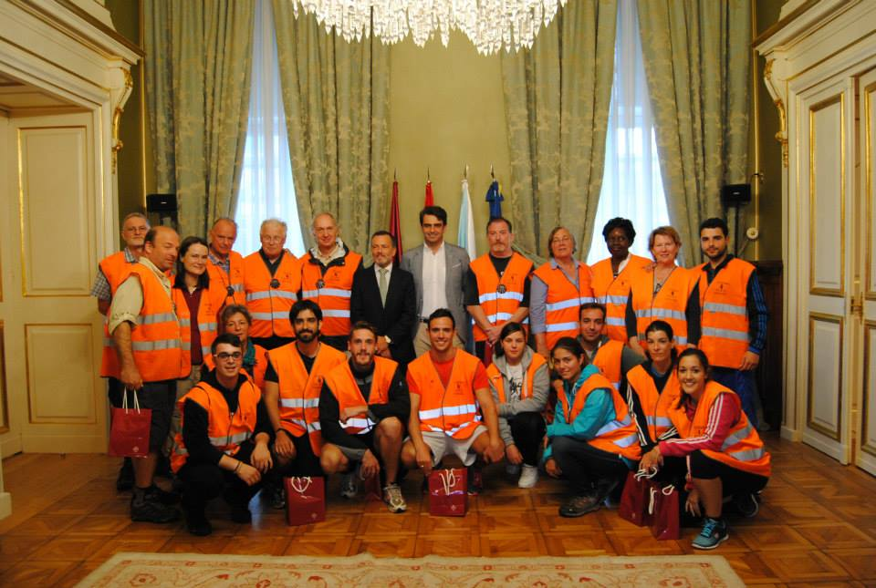

Issue 1

September 2015

Name of project

## Relevance to INTO members

In September 2014, this route was gone across by foot with part of the INTO Executive Committee. Anybody interested in this activity was invited to participate.

During five days the INTO members walked the 120 kilometres of the English Way from Ferrol to Santiago de Compostela.

Along the way, the eighteen municipalities that cross this route were visited and Simon Molesworth, Oliver Maurice and Bill Turner had the chance to meet their majors and speak about the situation of the route.

This event was used to disseminate the need and the opportunity that the application of sustainable criteria represents for the following:

- The environmental restoration: disseminated through social networks and photographs organized by INTO and United Nations (Global Partnership for Sustainable Tourism).

Economy dynamics: at the moment the touristic sector is the primary industry regarding PIB contribution, and the Pilgrim’s way is by far the main touristic attraction in Galicia.

However, the English Way is the less crowded route according to official data.

Parallel to this project, a book about the English Way was edited. Oliver Maurice wrote one of the texts included and so did Catherine Leonard. This book is going to be given to the attendants to the INTO Conference in Cambridge next September.

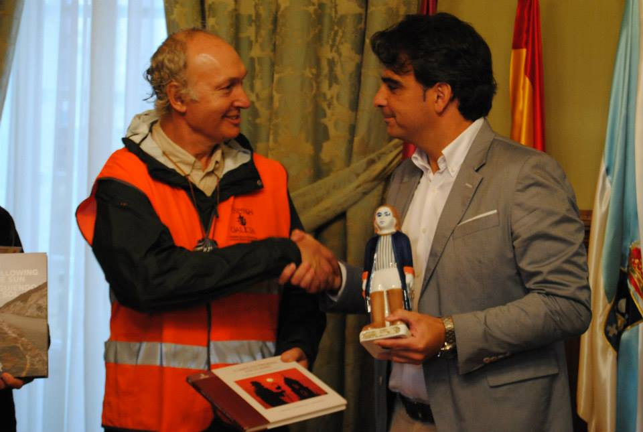

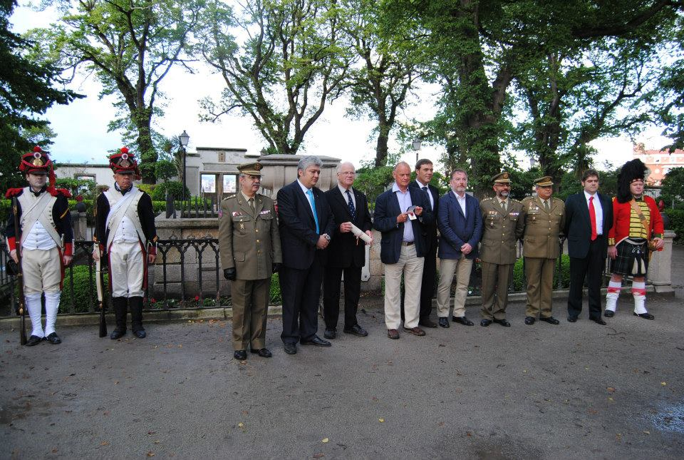

Currently there is a team working in several improvements such as:

- improving the signage along the route

- accesibility

- environmental measures

There is a project on hold to research and promote the interest of the English Way in its path around the British Isles.

### Progress

## Contact Information

**Tesouros de Galicia contact**

Tel: 0034 635 417 182

Praza Fundadores, s/n, Mondariz-Balneario, 36890 Pontevedra

E mail: adm@tesourosdegalicia.com

Website: www.tesourosdegalicia.com

**INTO Contact**

Tel 44 (0)20 7884 7157

20 Grosvenor Gardens, London, SW1W 0DH, UK

E mail: into@nationaltrust.org.uk

http://internationaltrusts.org

