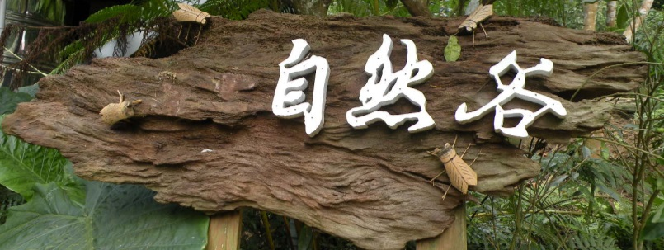

1. The landowners and TEIA signed a contract in 2014, TEIA will be the new owner and responsible for managing Nature Valley. The 2 sides have agreed on 3 main goals: 1. Grow and preserve law-altitude forest. 2. Engage the local community to support and participate in environmental protection activities, to merge the village into our “protected areas” and create Satoyama where people live in harmony with nature. 3. Manage Nature Valley as an environmental education site, so it’s accessible and benefits everyone.

For now, TEIA runs regular ecological survey and monitoring, monthly free guided tour, domestic trees planting, working holidays.

### Approach

Nature Valley is a low-altitude forest located in Taiwan, approximately 1.3 hectares in size, was originally an abandoned fruit farm. In 2008, 6 friends from different backgrounds who share the same passion for the nature, together bought a patch of land and named it Nature Valley, hoping that the forest and wildlife will grow back. However, the 2009 economic crisis effected the dream chasers, 3 of them had to withdraw their money. After this incident, the 3 friends left started to consider how to protect Nature Valley forever, they finally decided to donate the now forest to Taiwan Environmental Information Association, and set up the very first environmental charitable trust in Taiwan.

## Objective

Nature Valley 自然谷

Special points

of interest:

* Taiwan’s first Environmental charitable trust.

# Taiwan Environmental Information Association

Issue 1

September 2015

Name of project

## Relevance to INTO members

TEIA welcomes INTO members to visit Nature Valley.

### Progress

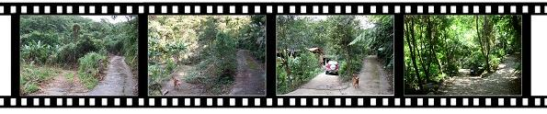

TEIA is currently lobbying for a Trust Act which will let conservation NGOs to easier acquire environmental charitable trust properties. We also hope that by making Nature Valley a successful case, more people will support environmental trust and hopefully there will be a second or third environmental trust site in the near future.

Meanwhile, after understanding what we are working on, another landowner in the community which Nature Valley locates in is willing to let us use his farm for free to practice organic farming, we now work closely with the local community and our volunteers. We believe one protected land brings one new hope, Nature Valley is our first step in Taiwan, we are sure there will be more in the future.

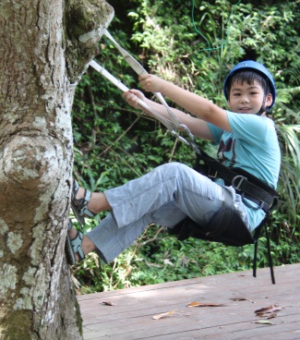



**TEIA Contact**

Tel: 886 (2) 29332233 ext.228

Address: No.38, Wanlong St., Taipei, Taiwan

E mail: teiaet@e-info.org.tw

Website: <http://www.e-info.org.tw>

**INTO Contact**

Tel 44 (0)20 7884 7157

20 Grosvenor Gardens, London, SW1W 0DH, UK

E mail: into@nationaltrust.org.uk

http://internationaltrusts.org

## Contact Information

