C:\Users\nicolae.RHP\AppData\Local\Microsoft\Windows\Temporary Internet Files\Content.Word\LOGO PRO PATRIMONIO 1.tif

The programme comprises a total of **74 wooden churches**, dating from the 18th-19th centuries, the majority of which are located in the counties of Hunedoara, Sibiu, Vâlcea and Gorj. These religious buildings were selected taking into account various **criteria**: urgency of the work, potential use, heritage value, tourism interest and local support. Most of the churches will be used by the community, as places of worship and/or as sociocultural centres, and there is generally heritage value and tourism interest in these buildings.

**Three phases** are proposed, with the emphasis on phase 1, the “action phase” consisting of a balanced mix of activities to complete the restoration of 8 “priority” churches and to prepare subsequent phases. Phase 2 includes the completion of 16 “medium priority” churches. Phase 3 involves completing other potentially viable schemes (some 20 churches). Assuming available finance, phase 1 could take place from early 2015 to end 2018; phase 2 from mid-2016 to end 2019, and phase 3 from mid-2017 to end 2020.

The 60 wooden churches in the counties of Hunedoara, Sibiu, Gorj, Vâlcea and other counties, all classified as historical monuments (categories A and B) are in an advanced state of decay, some of them in danger of collapse (according to research during 2007-2009). Field research has shown that about 80% of these churches are no longer functional, only 20% are still used for worship.

The restoration of these churches is vital for heritage conservation and for local community sustainable development, by raising interest in places of national heritage, using local craftsmen and attracting tourists.

The churches are small buildings but with some remarkable construction techniques and decorative painting, common in rural areas. Each monument has its own history, and the general deterioration is part of the wider phenomenon of contemporary rural landscape degradation.

The conservation work is made in partnership with the Chamber of Romanian Architects.

### Approach

## Objective

Wooden Churches of Oltenia, Romania

Special points

of interest:

Pro Patrimonio havealready restored

14 churches.

# Pro Patrimonio – the Romanian National Trust

Issue 1

September 2015

Name of project

## Relevance to INTO members

With the aim of encouraging visitors, it is proposed that the wooden churches are linked into **tourism circuits** with other monuments and heritage sites of higher attraction, such as the monastery at Horezu, the Cula museum and the Astra museum near Sibiu.

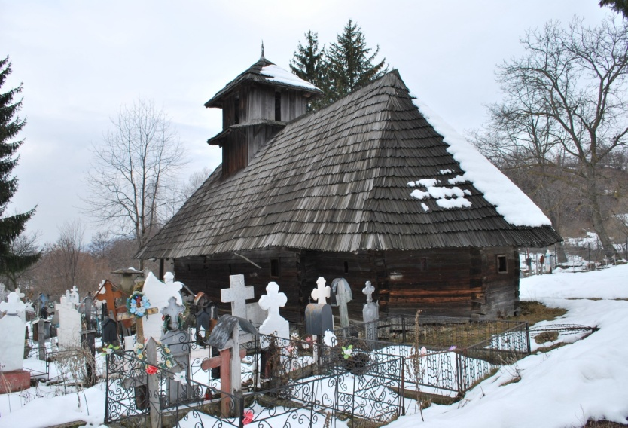

### 

C:\Users\nicolae.RHP\AppData\Local\Microsoft\Windows\Temporary Internet Files\Content.Word\LOGO PRO PATRIMONIO 1.tif

Heritage and financial experts from the leading European heritage organisation Europa Nostra and the European Investment Bank Institute visited representative wooden churches in Southern Transylvania and Northern Oltenia, listed among ‘The 7 Most Endangered’ heritage sites in Europe in 2014, and met with local, regional and national stakeholders to discuss the restoration and redevelopment strategies of these churches on 6-9 October 2014.

Contact Information

**Pro Patrimonio Contact**

[Tel:+44 207](Tel:+44%20207) 4860295

Address:18 Fitzhardinge Street

London W1H 6EQ

E mail:bucuresti@propatrimonio.org

Website: www.propatrimonio.org

**INTO Contact**

Tel 44 (0)20 7884 7157

20 Grosvenor Gardens, London, SW1W 0DH, UK

E mail: into@nationaltrust.org.uk

http://internationaltrusts.org

