During it’s campaign NTJ worked extensively with volunteers, local politicians, corporate sponsors, local media and other conservation bodies. Effective stakeholder engagement resulted in the submission of a 10,300 signature petition to the Chief Minister of The States in Jersey in 2006 calling for the site to be acquired for the benefit of the Islands and, in 2009, a demonstration was held in St Ouen’s Bay whereby 7,000 people joined hands to form “a line in the sand” to halt inappropriate development on Jersey’s coastline. This provided the stimulus for the subsequent creation of Jersey’s Coastal National Park.

As well as organising the petition and demonstration, in 2006 NTJ launched a Coastline Campaign, sponsored by HSBC, which was promoted though a series of walks, talks and specially commissioned films entitled Wild North, Wild West and Wild East. The puffin was used as a logo for the Coastline campaign as Plémont is the only location in Jersey where a small population of 4 to 8 pairs regularly nest.

In 2012 the Trust launched Love Plémont in order to support a proposition being brought to the States of Jersey to acquire the site. The campaign encouraged local residents to send “heart-shaped cards” to their local politicians urging them to support the proposition. This was backed up by a Love Plémont website page, social media, car stickers, email and letter writing.

Although the proposition failed by one vote, the campaign provided a firm foundation for a successful subsequent bid in 2014.

Special points

of interest:

*Do not compromise your key objective

*We focused on generating community engagement across the Island

*Partnering with government ended up with the right outcome.

*Aim to work with a media partner to help raise profile.

*The Puffin campaign mascot helped to provide an emotional connection with supporters

*Never give up it took NTJ 14years !

The Love Plémont project has resulted in the safeguarding of a 11.3 acres of coastal headland located in the north west of Jersey in the Channel Islands. The site is of considerable strategic landscape importance, archeological significance and is adjacent to the last remaining colony of puffins on the Islands.

Plémont had been blighted with the development of a series of holiday camps from 1936 onwards and then, when such holidays went into decline, the site became vulnerable to redevelopment proposals commencing with an application in 1998 for 117 residential units. In January 2000 The National Trust for Jersey (NTJ) began campaigning for the site to be “returned to nature”

### Approach

## Objective

Love Plémont

# The National Trust for Jersey

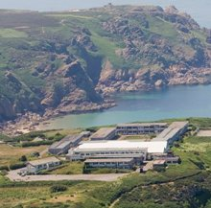

September 2015

The Campaign to safeguard Plémont demonstrated immense tenacity, perseverance and commitment on many levels. Ultimately, the campaign was effective as it secured the right outcome, but most importantly it engaged the local community in debating, demonstrating and ultimately supporting the need to protect Jersey’s coastline. With limited resources both in terms of staff and money, this campaign was delivered on a financial shoe string, and only succeeded due to the passion, generosity and foresight of its many supporters across the community.

* Have a ”Vision” that people can easily relate to.
* Network your Council members and get them to network for you to promote your campaign.
* You don’t always need a large team or expensive consultants!. You would be surprised what can be delivered “in House” with a team of volunteers & supporters from Funding, Marketing, PR, and Admin support.
* Take your campaign onto the streets.

Name of project

## Relevance to INTO members

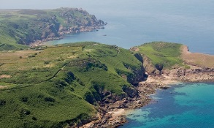

### Progress

The Trust managed to raise over £8,150,000 for the acquisition and landscaping of Plémont ranging from a government grant of £3,075,000 to small donations of £10 from local residents. It is estimated that the overall campaign expenditure was in the region of £10,000 to £15,000.

Finally after 14 years, the Trust acquired the site on 25th July 2014 for the sum of £7.15m. The sale price reflected that the owners had secured planning consent for the development of 28 houses, subject to the outcome of a third party appeal.

The Trust has now cleared the site of buildings. Landscaping works are being undertaken to enhance wildlife value and public accessibility by recreating a species-rich heathland that will benefit such species as Green Lizards, Dartford Warblers and Grass Snakes.

The Love Plémont campaign was completed on time and on budget, and has been recognised for two awards ; The NGO Impact Award from the Chartered Institute of Ecology and Environmental Management and The Channel Islands Insurance Corporation for the Best Conservation Project.

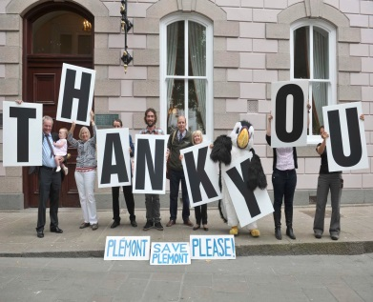

## Contact Information

**Organisation Contact**

Tel: Charles Alluto

Address: The National Trust for Jersey

The Elms, La Chève Rue, St Mary, Jersey JE3 3EN

E mail:Charles@nationaltrust.je

Website:www.nationaltrust.je

**INTO Contact**

Tel 44 (0)20 7884 7157

20 Grosvenor Gardens, London, SW1W 0DH, UK

E mail: into@nationaltrust.org.uk

http://internationaltrusts.org

