Special points

of interest:

* The Farnsworth House is a National Historic Landmark designed by renowned architect Mies van der Rohe.
* Please visit FarnsworthProject.org for more information on research and options.

Conceived by internationally renowned architect Mies van der Rohe as a country retreat for Dr. Edith Farnsworth, the house – one of only three residences he designed in the U.S. – was built in 1951 and is significant for the single, geometric form in a pastoral setting, which reinforces the architect’s statement about the potential of a building to express “dwelling” in its simplest essence, and the landscape, an integral aspect of Mies’s aesthetic conception, which has the house – raised 5 feet 3 inches above the ground – facing the Fox River just to the south.

A National Historic Landmark, Farnsworth House is perhaps the fullest expression of modernist ideals that had begun in Europe, but which were fully realized in Plano, Illinois.

Since the National Trust assumed ownership of the site in 2010, the incidence of river flooding has increased. This pattern will continue as the Fox River is a developing watershed.

### Approach

To help determine the possibilities for flood mitigation, the National Trust commissioned an initial study by internationally-respected hydrology firm Wright Water Engineers. A structural engineering firm, Thornton Tomasetti, analyzed the options provided by WWE and reviewed other critical elements.

A technical advisory panel of national and international experts was assembled in November 2013 to review the initial findings and suggest a course of action. While a variety of options were proposed, the two that are currently considered by the panel include:

* Elevating the house, temporarily, utilizing a hydraulic system;
* Moving the house, either to higher ground on the site, or completely off the site to a new location.

## Objective

Farnsworth House

# National Trust for Historic Preservation

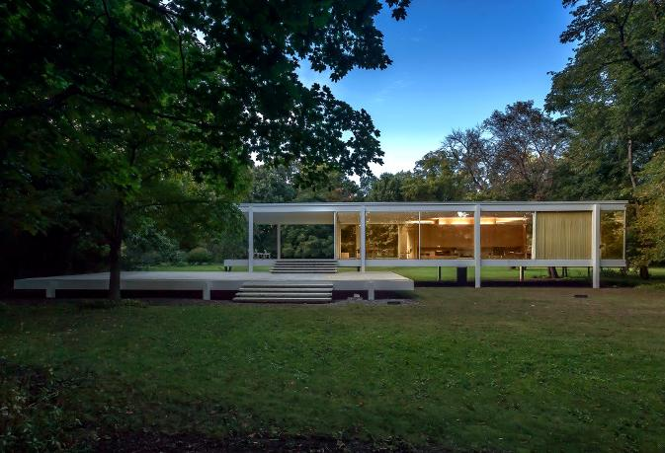

Issue 1

September 2015

Name of project

## Relevance to INTO members

It was recognized that there were no simple or right solution. A website, FarnsworthProject.org, was created, and four public meetings were held, including a presentation in front of our easement holder and partner, Landmark Illinois. The National Trust also conducted peer reviews with other engineers and with many of our preservation partners.

It was clear from the public feedback that each option had supporters and detractors. While there was strong support for the lift, it was not unanimous and there were a few strong public voices speaking out against this approach. The criticism was that the solution was not passive and too dependent on mechanical parts.

The National Trust assessed the feedback and decided to conduct follow-up studies, including examining the cultural landscape and viewsheds of the Farnsworth House.

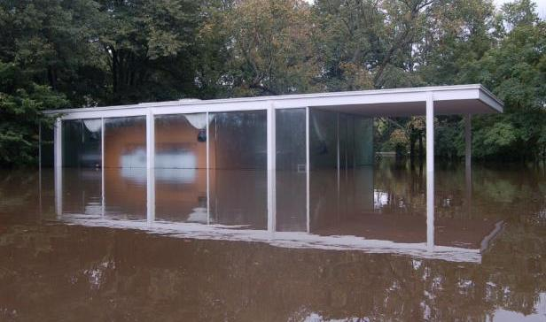

### Progress

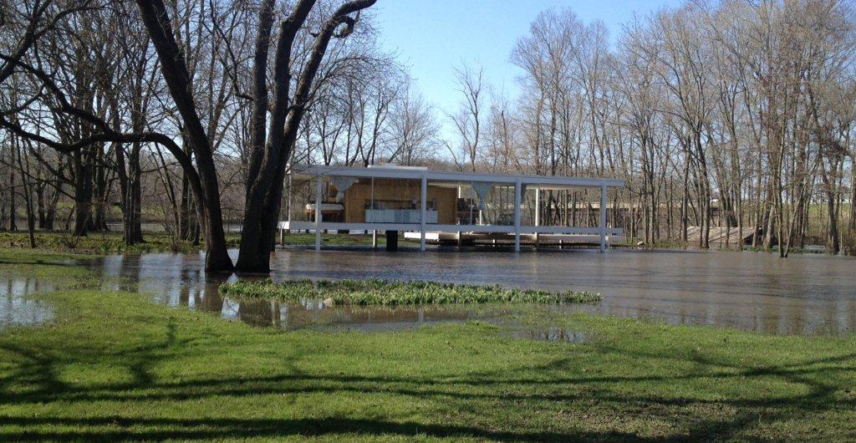

The National Trust applied to the Farnsworth House easement holder, Landmark Illinois, for conceptual approval of both the hydraulic lift and the relocation to a new location on the site (with the lift option preferred) in summer 2015. The board of Landmarks Illinois will vote on the conceptual approval by late summer.

## Contact Information

**Organisation Contact**

Tel: (202) 588-6227

2600 Virginia Avenue NW Suite 1100

Washington, DC 20037

E mail: feedback@savingplaces.org

http://www.preservationnation.org

**INTO Contact**

Tel 44 (0)20 7884 7157

20 Grosvenor Gardens, London, SW1W 0DH, UK

E mail: into@nationaltrust.org.uk

http://internationaltrusts.org



