Special points

of interest:

* Heritage sites may be in communiities on State land, but it does not guarntee their conservation.
* Pulling community heritage organisations together under one banner is the solution.
* In a case where a World Heritage Site united heritage organisations – it also divided them.
* Instead of isolated voices, the combined “clout” of many like minded groups could win.

The South Africa’s mountainous Cape Peninsula stretches from Table Mountain to Cape Point, a distance of about 90 KM.   
After Cape Town and Simon’s Town, Hout Bay is the third oldest surviving settlement in the country. Located on the Atlantic seaboard, it once served as an important winter anchorage and refuge for “East Indiamen” sheltering from winter storms encountered between Simon’s Town and Cape Town.  
In 1998 the members of Hout Bay’s Heritage Trust were elated to hear that most of the Cape Peninsula was to become “Table Mountain National Park” (TMNP), a World Heritage Site covering 75% of the Peninsula, the largest Urban Park in the Country.   
The Park was proclaimed for its rich and unique biodiversity and with the help of International support it has become World famous. Table Mountain has since been elevated to become one of the modern natural wonders of the world.

But there is a sting in this “tale”.  
Whilst the Park has been funded to conserve its bio-diversity – many of its cultural heritage sites have been left to decay and the heritage authorities have seemingly turned a blind eye.  
In 2000 a massive bush fire swept the Peninsula and substantial damage was done to the c.1783 East Fort on the slopes of the mountain overlooking Hout Bay. The damage included the old guns and carriages and the Trust resolved to pioneer their restoration. Various attempts were initiated to get the help of the heritage authorities and the Park without success. However, in 2002 the 8 x 18 pdr guns were proofed and licensed. According to Guinness Archives they rate as the oldest working battery of original guns in the World.

## A catalyst for Cape of Good Hope Heritage Trust.

Whilst there are at least a dozen community conservation groups around the Peninsula sharing the proximity and pride of a World Heritage Site, there has been a severe impediment preventing their collaboration – a 3000 ft mountain chain which made frequent contact difficult. Whilst the mountains united them it also divided them.

There has been more than one attempt to get a National Trust off the ground in SA led mainly by heritage practitioners, but they have failed. Our feeling is that they tried to create a ‘Top Down” model in a large and diverse country and we believe that we should adopt the “Bottom Up” approach by linking community heritage organisations together as primary building blocks, firstly into regional organisations and eventually into a National Organisation. But how do we go about it?

**The unforeseen catalyst.**  
In May of 2015, SA National Parks invited stakeholder comment for its coming ten year Development Management Plan for Table Mountain National Park. It was clear that the Plan was a generic design for all SA National Parks with special adaptations for the TMNP.  
All conservation organisations around the Peninsula were invited to comment as stake holders to the 155 page plan and 205 pages of Annexures.

How can we get a new   
National Trust on the map?

### The Approach

# Hout Bay & Llandudno Heritage Trust

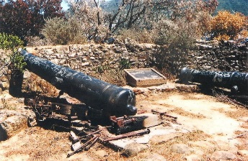

Issue 1

September 2015

Name of project



## Relevance to INTO members

It was clear to us that most respondents would abandon the idea of an incisive critique of the documents. However, we saw it as a great challenge to highlight not only our problems, but to suggest that similar problems existed elsewhere for other organisations in the Peninsula.   
Following the due date for submission we also circulated our response to the other Peninsula groups. We also included the City of Cape Town’s Community Projects Development Dept which precipitated a significant response, especially to our comments about the Park’s apparent indifference to the conservation of cultural heritage sites.  
We were subsequently invited to address several of the City’s Councilors representing the abutting Wards around the TMNP who showed significant interest sharing their similar experiences. The City has agreed to host discussions with conservation body’s representatives and City Councilors from the TMNP abutting Wards in the near future.   
**Community Profiles.**The fact is thatmost of our community heritage groups consist of retired or older people, fiercely protective of their community’s heritage. They distrust developers and most authorities. They are all looking for more members, find it expensive to print newsletters as they did in the past, but have a wealth of talent and have unsurpassed understanding of the “local lore” of their communities.  
How can we pull them together so that they can get the earnest attention of the authorities who ignore them?

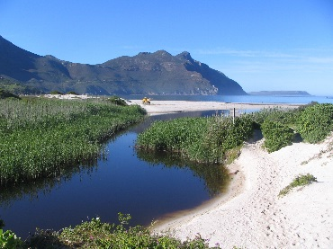

### Progress

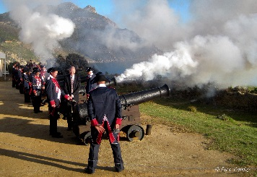I

The first progressive step to draw them under one banner has been the creation of the domain name of “capeofgoodhopeheritage.org”where collaborating groups can host newsletters which can reach a much wider audience than ever before. The newsletters will follow a similar recipe and be a method whereby groups can communicate with other bodies in the Peninsula. The common goal will be to resuscitate the Cape of Good Hope as an International historic destination which will attract domestic as well as International interest. We still have a long way to go, but the way is clear. We still need to find the people who can handle the IT needs in various areas, but it is an exciting challenge which we will soon overcome.  
We will also be able to tell SANParks what we are doing to help them and hopefully they will help us in return.

## Contact Information

**Organisation Contact  
Dave Cowley**

Tel: +27217902008

Address: 22 Manchester St, Hout Bay,  
Cape Town, 7800 Western Cape, RSA

E mail: HB.Heritage@zsd.co.za

Website: www.houtbayheritage.org.za

**INTO Contact**

Tel 44 (0)20 7884 7157

20 Grosvenor Gardens, London, SW1W 0DH, UK

E mail: into@nationaltrust.org.uk

http://internationaltrusts.org

