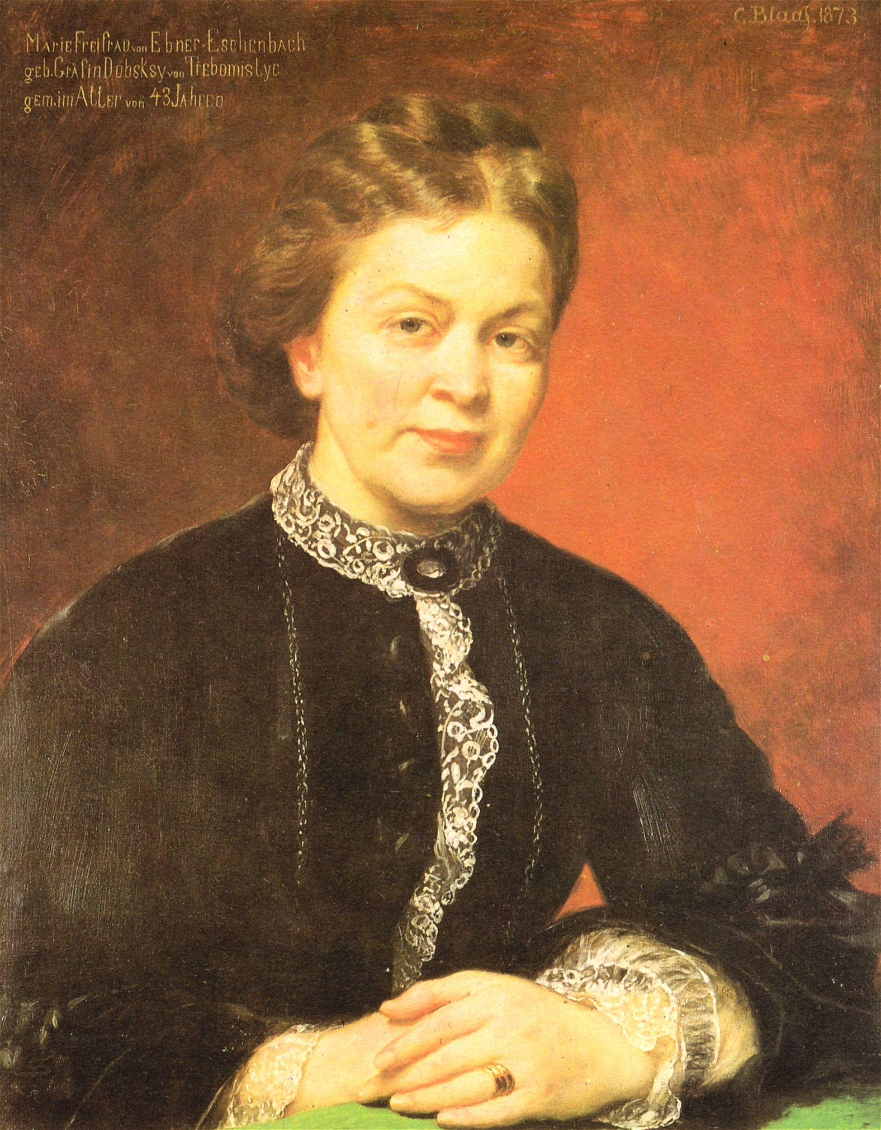

Marie von Ebner-Eschenbach

A forgotten Czech writer and woman of many talents

Marie von Ebner-Eschenbach is one of the most remarkable female writers of the 19th century. Born into a Czech family and inspired by Czech culture and land to write her stories, plays and novels, after the break-up of the Austro-Hungarian empire she is practically unknown to the Czech people, although she remains a household name in Austria and Germany.

The Czech National Trust aims to restore a part of the landscape that inspired her literary work as its pilot project – an overgrown parkland, once lovely but now forgotten, includes an interesting building of a small domed chapel with a tomb of the writer and her family. A chateau where the author lived, stands nearby, also unused and in a state of disrepair.

The situation that lead to the unfortunate condition of these heritage objects is a combination of negative impacts which are typical for many other historic sites in the country – decades of intentional destruction during the communist regime followed by unclear ownership in the new democracy, resulting in ongoing neglect and dilapidation.

Czech National Trust aims to clear the area, open it to public, and also to commemorate the 100th anniversary of Marie von Ebner-Eschenbach’s death in 2016.

### Approach

The chapel and tomb stands in the middle of the park, both originally in different hands – the park was in private hands of the descendants of original owners (now living in Brazil) while the building is owned by the regional authority.

The trust initiated necessary structural reinforcement of the building that is now being carried out by the current owner and funded from state resources. After the completion the regional government shall donate the building to the Czech National trust who will raise funds for further reconstruction, open the building to public and hold various events there in collaboration with the local community.

The surrounding park is a different story – here the trust acted as a bridge between the actual owner and the local authorities, and managed to obtain the surrounding land from the owner, who donated 2 hectares of the parkland in 2015. Initial clearing started immediately and will be followed with further cutting, clearing and regeneration work done both by professionals and volunteers during working parties and NT working holidays.

## Objective

Special points

of interest:

* Czech first property in trust ownership, introducing a “lost” piece of history
* Trust acts as bridge between owner and authorities and aids communication
* Reconstruction and opening facilitated by volunteers

# Czech National Trust

Issue 1

September 2015

Name of project

## Relevance to INTO members

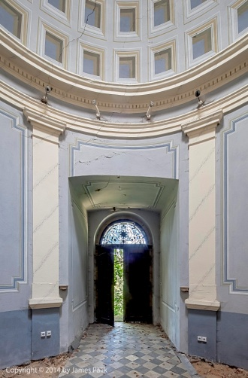

INTO has substantially helped the Czech National Trust in the initial phase of its existence through personal support of its leading representatives – Oliver Maurice has spoken at the very first presentation of the newly established trust in the Czech Republic, Catherine Leonard and Justin Albert have personally supported our efforts and our pilot project presentation at the official launch of the CNT in London, June 2014.

A great help has been the opportunity of Candidate membership for the CNT in 2014. Being a part of a distinguished international organisation gave us the strength and credit to become respected partners in communication with our partners, sponsors and supporters in the Czech Republic, and mainly in the discussions leading to the very first historic property ownership by a national trust-type organisation in the Czech Republic – 2 hectares of historic parkland from a donor and an anticipated transfer of the chapel and tomb from regional authority.

### Progress

INSERT IMAGE

The Czech National Trust now owns 2 hectares of land obtained through donation. Clearance works are taking place to be followed by rescue management of trees.

The trust initiated a much needed reinforcement of the chapel and its foundations that is now taking place courtesy of regional government and state funding.

The trust team is working in close collaboration with the regional government and local communities to take over the building in autumn/winter 2015.

Together with other institutional partners the events commemorating the author will take place in 2016.

Fundraising campaign has been launched to raise funds towards full reconstruction.

The site will be open to public in 2016. A project will follow with the aim to establish a visitor centre and basic facilities.

## Contact Information

**Organisation Contact**

Tel: +420 603 417 946

Address: Czech National Trust, Mlynska brana, Snemovni nam. 2/4, 767 01 Kromeriz, Czech Republic

E mail: info@czechnationaltrust.org

www.czechnationaltrust.org

**INTO Contact**

Tel 44 (0)20 7884 7157

20 Grosvenor Gardens, London, SW1W 0DH, UK

E mail: into@nationaltrust.org.uk

http://internationaltrusts.org

