This Lighthouse Matters Competition and Crowdfunding



Lighthouses are symbols of our country’s proud Maritime heritage and deeply linked with Atlantic Canada’s culture, memory and identity. Canada’s lighthouse matter –

and they are at risk:

Once owned almost exclusively by government, many have already been lost, some are already in the hands of local groups struggling to find funds, and hundreds more have been declared surplus and are in need of communities with the means to take them on.

Despite national legislation to protect them, lighthouses are an endangered species.

This summer, the National Trust and the Nova Scotia Lighthouse Society launched **THIS LIGHTHOUSE MATTERS** – a strategy for saving Nova Scotia’s lighthouses and encouraging economic renewal for many of the province’s challenged communities.

### Approach

We know that with seed funding, many historic lighthouses can be preserved and repurposed to generate economic and tourism activity. **THIS LIGHTHOUSE MATTERS** isa groundbreaking first of its kind crowdfunding website and competition platform that allows groups with worthy heritage projects to compete for cash prizes and raise dollars through crowdfunding, using new technology and social media. We raised $250,000 this year with the help of three well-connected champions. We launched the competition platform on June 17, and 26 projects competed enthusiastically. Social Media played an important role, with people spreading the word via Instagram, Facebook and Twitter.

**THIS**

## Objective

Special points

of interest:

* $250,000 CDN raised
* 220,000 votes cast
* 5.5 million Canadians reached

# National Trust for Canada

Issue 1

September 2015

Name of project

## Relevance to INTO members

We could have distributed the funds using a traditional granting approach. However we learned how powerful the “game-ification” of heritage funding could be in attracting substantial attention from the general public and the media.

**THIS LIGHTHOUSE MATTERS** was made possible thanks to generous funding from the RBC Foundation, the Telus Atlantic Community Board and individual donors.

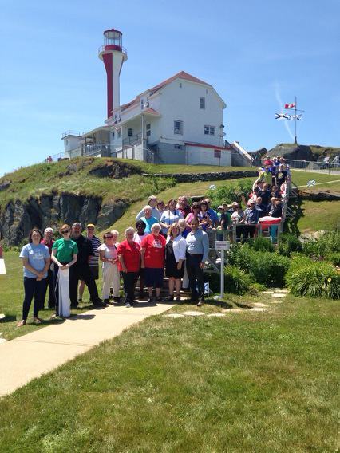

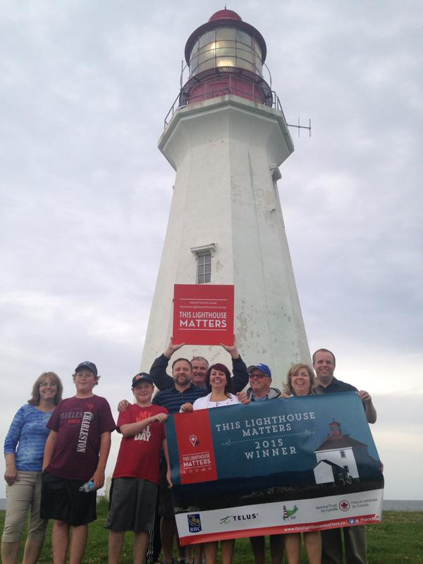

G:\5 New Initiatives\Save Canada's Lighthouses\Save Nova Scotias Lighthouses Fund\7 - Campaign Materials\Signs\Podium sign.tif

### Progress

**THIS LIGHTHOUSE MATTERS** was a media sensation, reaching approximately 5.5 million Canadians. After 4 weeks of intense competition that mobilized a new generation of lighthouse supporters, 9 worthy lighthouse project groups shared the prize pool of $250,000. But in fact every lighthouse was a winner: Through crowdfunding, the 26 projects raised an additional $50,000. These lighthouse groups will use their prize money to regenerate heritage landmarks.

## Contact Information



**National Trust for Canada Contact**

Tel: +1 613-747-4262

Address:

E mail: nbull@nationaltrustcanada.ca

Website: [www.nationaltrustcanada.ca](http://www.nationaltrustcanada.ca)

**INTO Contact**

Tel 44 (0)20 7884 7157

20 Grosvenor Gardens, London, SW1W 0DH, UK

E mail: into@nationaltrust.org.uk

http://internationaltrusts.org